Manufactured solution for DSM2-STM verification
Governing equation:
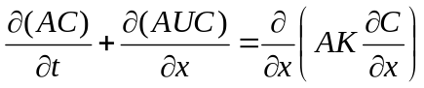
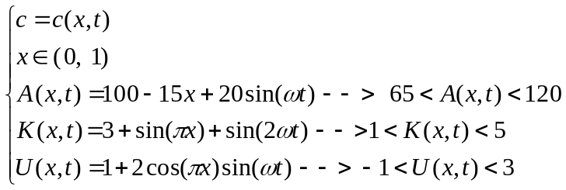
I am not sure if I should introduce U or not
No restriction on the boundary condition and initial condition, they will be appear automatically after choosing the function for manufactured solution
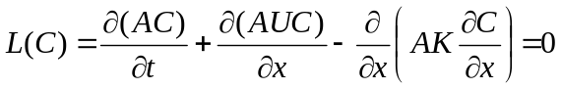
The above is governing equation in a very general form (area, velocity and dispersion coefficient are function of time/space), since the method of manufactured solution is a general concept, any solution for C can be picked regardless of the governing equation
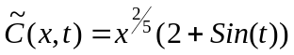
It seems the function which is picked for MMS must not vanish in governing equation, so for Advection Diffusion, C must be from at least from C¹ space in x domain and C⁰ space in time domain (the above C is always smooth or C∞ space)
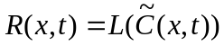
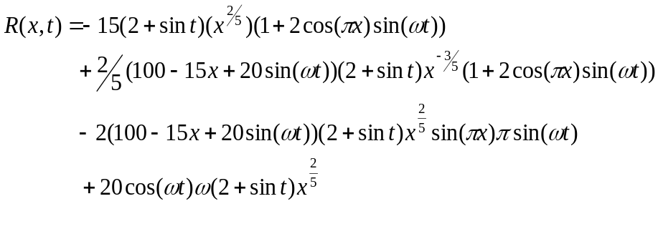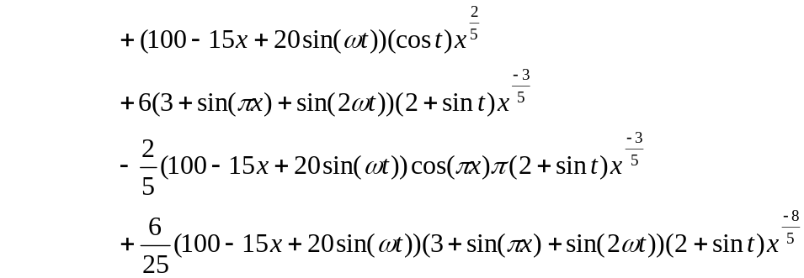
(-15*(2+sin(t))*x^(2/5)*(1+2*cos(pi*x)*sin(w*t))
+2/5*(100-15*x+20*sin(w*t))*(2+sin(t))/x^(3/5)*(1+2*cos(pi*x)*sin(w*t))
-2*(100- 15*x+20*sin(w*t))*(2+sin(t))*x^(2/5)*sin(pi*x)*pi*sin(w*t)
+20*cos(w*t)*w*(2+sin(t))*x^(2/5)
+(100-15*x+20*sin(w*t))*cos(t)*x^(2/5)
+6*(3+sin(pi*x)+sin(2*w*t))*(2+sin(t))/x^(3/5)
-2/5*(100-15*x+20*sin(w*t))*cos(pi*x)*pi*(2+sin(t))/x^(3/5)
+6/25*(100-15*x+20*sin(w*t))*(3+sin(pi*x)+sin(2*w*t))*(2+sin(t))/x^(8/5))
So the modified equation is:
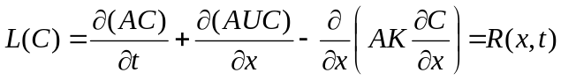
Subjected to the initial condition:
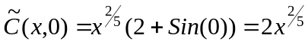
And the Neumann - Neumann (no out flow gradient) boundary condition:
